CS663 – Project 02 Proposal

Real-Time Object and Text Detection for Accessibility

Course: CS663 – Computer Vision
Instructor: Prof. Lynne Grewe

Group 04:
Sarmad Habib
Muhammad Sufiyan
Anas Niaz
Jaskirat Singh

Date: 14 October 2025

1. Goal Statement
This project aims to develop a mobile accessibility system that assists low-vision or blind users by detecting obstacles, reading text, and providing concise spoken feedback.
The system combines on-device real-time computer vision (using TensorFlow Lite and OpenCV) with Google’s Gemini model to produce natural, structured, and spatially aware narrations.

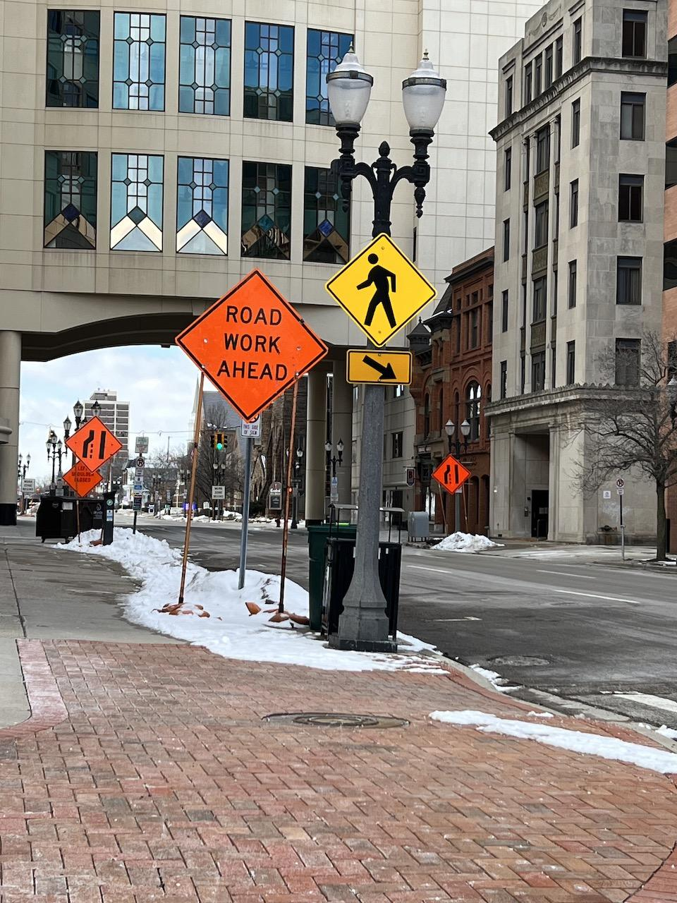
Figure 1: Example Input Scene – Street signs and pedestrian crossing area captured by the smartphone camera for real-time detection and text reading.

1.1 Motivation
Traditional object-detection systems for visually impaired users struggle to convey context - for example, “a bench on your left” vs. just “bench detected.”

By integrating Gemini (base model), this project enhances user understanding with short, meaningful narrations like “Curb ahead; bench left.”

The design avoids high-latency live streaming and instead uses snapshot-based Gemini calls for efficient, privacy-friendly, and realistic performance on mobile hardware.

2. System Overview
The system consists of two complementary layers:

On-Device Layer:
Performs fast object detection (YOLO-N or PP-PicoDet) and text recognition (OCR) for immediate hazard alerts and text reading.

Cloud Layer (Gemini)
Every few seconds—or upon user request—the system sends a single image snapshot and detection summary to Gemini. Gemini returns structured JSON plus a one-line narration describing spatial relationships and nearby objects.

This approach balances speed (on-device) and semantic richness (cloud).

3. System Diagram

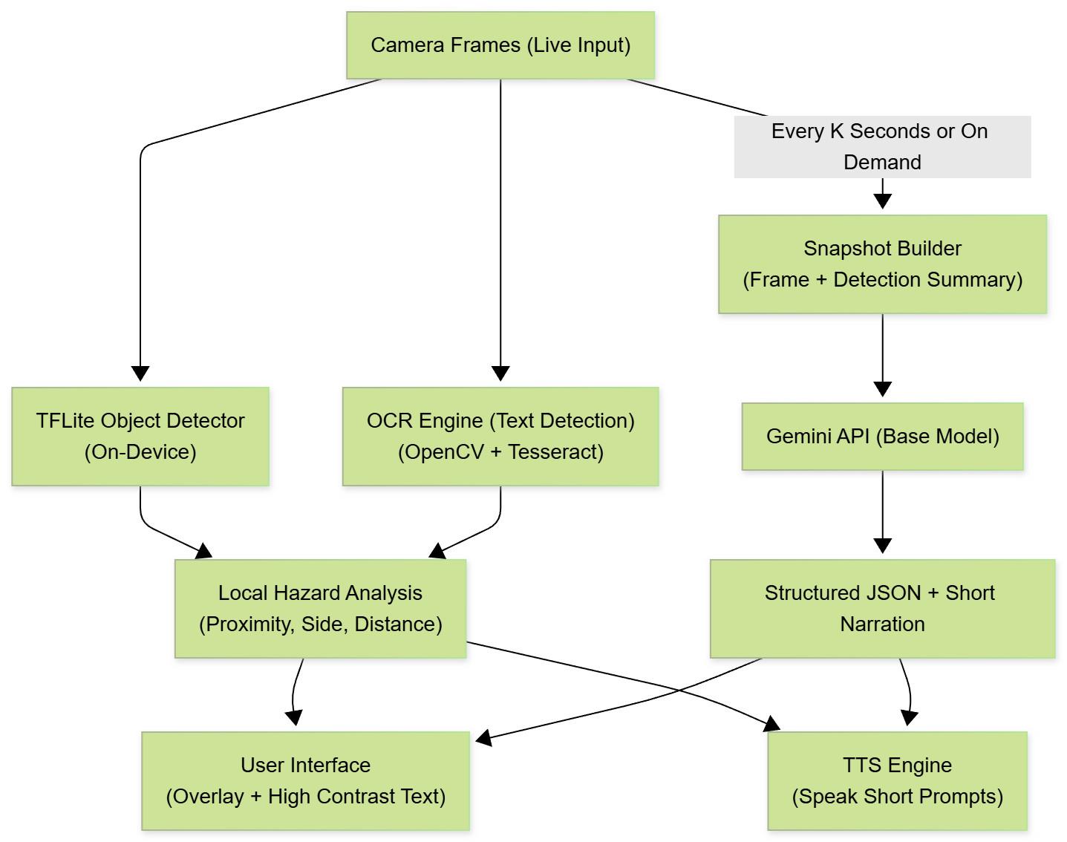
Figure 2: System Architecture for Gemini-Assisted Real-Time Object and Text Narration

4. Algorithms (Sidewalk-Focused, brief)

4.1 Object Detection (on-device, 15–30 FPS)

Model: YOLO-N or PP-PicoDet → TFLite.

Classes (trimmed): person, dog, stroller, wheelchair, bike/scooter, cone, barrier, trash_can, pole/bollard, bench, tree/planter, curb, ramp, crosswalk, vehicle_on_sidewalk.

Side & distance:

side ∈ {left, center, right} via bbox center vs. image center (±15% band = center).

distance ∈ {near, mid, far} from bbox height thresholds tuned to our camera/FOV.

(Optional) In-path gating: apply a simple sidewalk/walkway mask to flag only obstacles in the walking path.

4.2 Text Recognition (OCR)

OpenCV preprocess (grayscale → threshold/denoise → deskew) → Tesseract/ML Kit.

Keep short, navigation text only (e.g., “STOP”, “SIDEWALK CLOSED”, “DETOUR”).

4.3 Snapshot → Gemini (prompted JSON)

Send: current JPEG + detection summary (objects + boxes + OCR).

Return (schema):

{"objects":[{"label":"cone","side":"center","distance":"near"}],

"text":[{"content":"SIDEWALK CLOSED"}],

"narration_short":"Cone ahead; step down at right curb."}

Narration rule: ≤12 words, action-first, sidewalk-relevant.

Offline fallback: if Gemini off, app still shows overlay + speaks local prompts.

5. Datasets

5.1 Primary (sidewalk domain)

Sidewalk images with curb/obstacle/crosswalk labels — used to fine-tune our detector and evaluate per-class P/R and an in-path hazard F1 (after walkway gating).

5.2 Pretrain / generalization(Optional)

MS COCO (2017) to bootstrap common objects; (optional) BDD100K for street context before sidewalk fine-tune.

5.3 OCR robustness (eval only)

ICDAR15 / ICDAR17-MLT / COCO-Text / Total-Text to check rotated/curved/multilingual text.

5.4 Splits & metrics

Splits: 80/10/10 if none provided.

Metrics: detection mAP@0.5 + per-class P/R; In-Path Hazard F1; OCR F-score on nav words; latency (on-device + snapshot round-trip).

• Option A - One dataset (works if sidewalk set is labeled):
- Train: detector on the Sidewalk dataset (with labels like cone/curb/crosswalk).
- OCR: use Tesseract/ML Kit as-is (no training).
- Gemini: prompt only (no training).
- Demo/Test: use some sidewalk images from the same set.
• Option B — Tiny but safer (two datasets, recommended):
- Train: detector on MS COCO (common objects; faster to get working).
- Test/Demo: your Sidewalk images (to show it works on sidewalks).
- OCR: Tesseract/ML Kit (no training).
- Gemini: prompt only (no training).

6. Graphical User Interface (GUI)
The proposed mobile interface for Object and Text Assistance for Low-Vision Users focuses on simplicity, clarity, and accessibility. The design follows a snapshot-based workflow rather than continuous live video, ensuring privacy, low latency, and ease of use for low-vision participants.

6.1 Design Philosophy
The GUI is built with a low-vision–first approach, prioritizing large touch targets, high-contrast visuals, minimal text, and immediate voice feedback. All interactions are designed to require a single tap or voice confirmation, minimizing cognitive load and visual dependency.

6.2 Layout and Navigation
The app consists of two primary screens:

(a) Capture Screen
- Displays a clean camera viewfinder that mimics a live camera, guiding the user to center the sidewalk or street area.
- A large “📷 Take Picture” button occupies the lower portion of the screen, allowing easy activation with minimal effort.
- Once a photo is captured, the system automatically processes the image and transitions to the narration view.
- Subtle voice guidance (e.g., “Camera ready. Double tap to take a picture.”) helps orient the user upon launch.

(b) Narration Screen
- Shows a concise, high-contrast line of text (≤12 words) representing the spoken narration, e.g., “Careful: ramp ahead; pedestrian crossing in 3 meters.”
- The narration automatically plays using the Android Text-to-Speech API after each capture.
- Includes two simple controls:
  - “▶︎ Play Again” – replays the spoken narration.
  - “↺ Retake Photo” – returns the user to the capture screen.
- Below the narration, a small summary lists detected items (object label, side, and distance) using clear tag-like chips, e.g., “ramp • center • near”.

6.3 Accessibility Features
- Voice Guidance: All key actions provide spoken prompts and confirmations.
- Contrast and Font Legibility: Large font size (~19 px) and black-on-white color scheme for high readability.
- Minimal Controls: Only two main screens with essential actions, ensuring users are not overwhelmed.
- Auto-Processing: The app begins analysis and narration immediately after photo capture, eliminating extra steps.

6.4 Usability Alignment
The interface aligns with the project’s academic goals by supporting accurate evaluation of:
- Latency (photo capture → narration output),
- Narration correctness (spatial and distance accuracy), and
- System Usability Scale (SUS) scores for low-vision participants.
Overall, the GUI provides an intuitive and accessible experience that reflects the project’s emphasis on clarity, structured narration, and low-effort interaction.
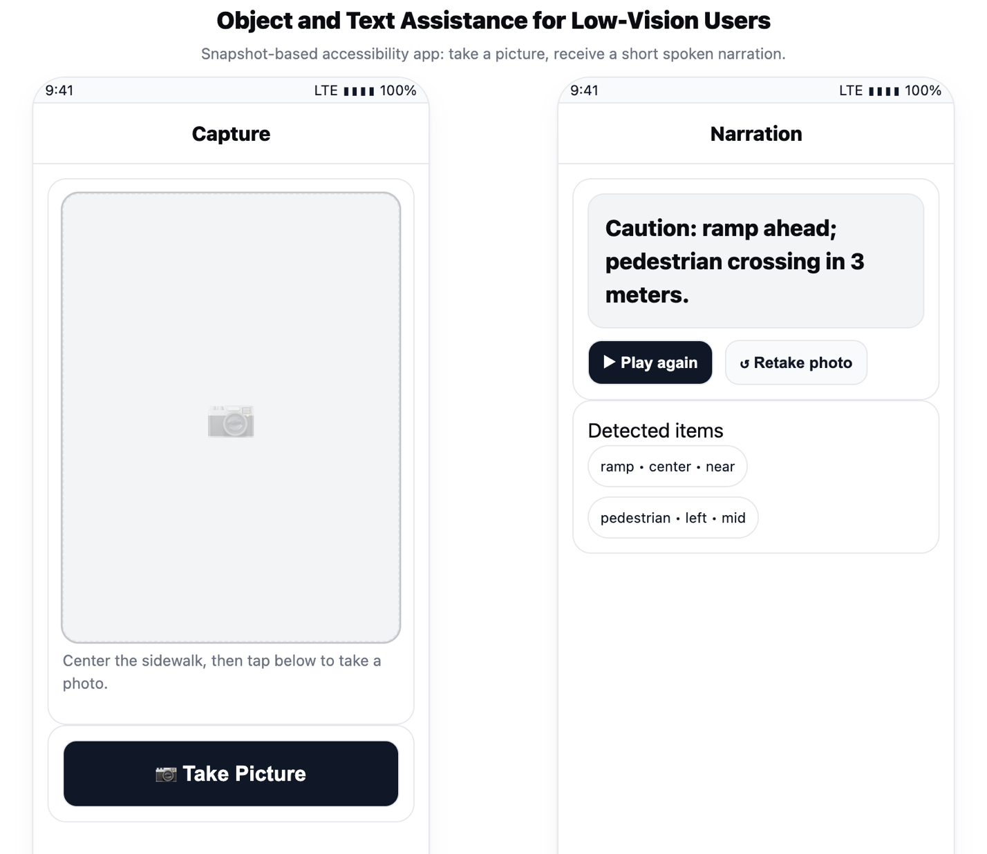
Figure 3: Prototype interface for the Object and Text Assistance app.

